This Project 4 will cover:

MySQL as CUD operations and Kafka Producer.

MongoDB as R operation and Kafka Consumer.

As soon as the CUD operations happen in MySQL, the same will be updated in the MongoDB as a replica.

Sending the type of CRUD operation from Producer to Consumer via Kafka.

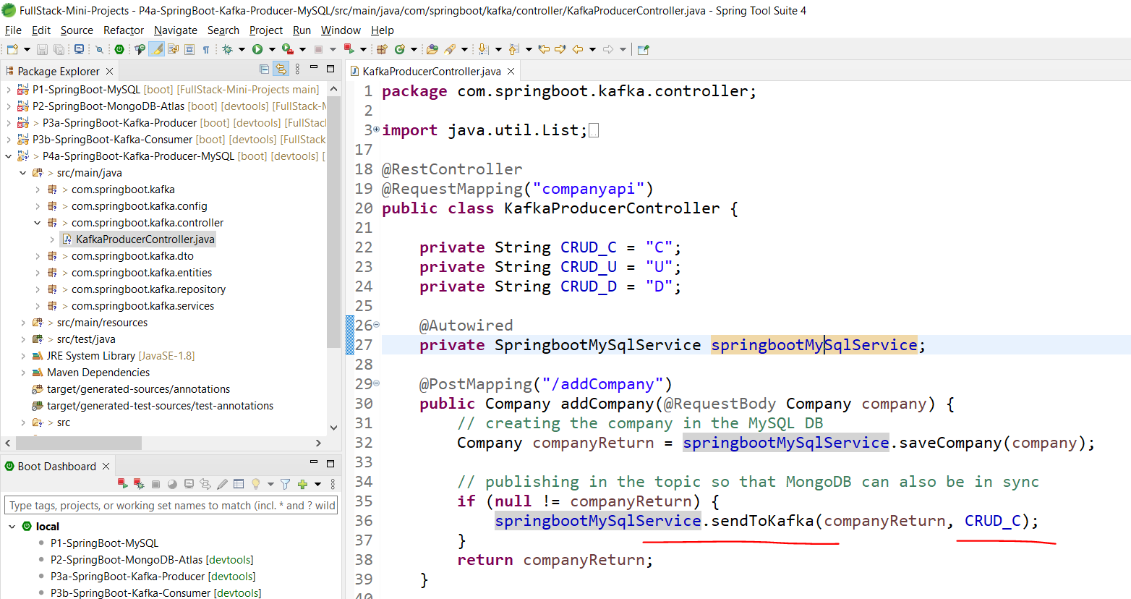

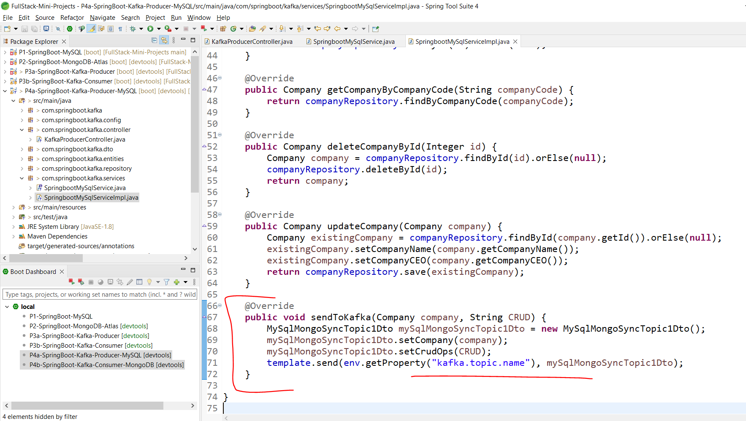

In Consumer:

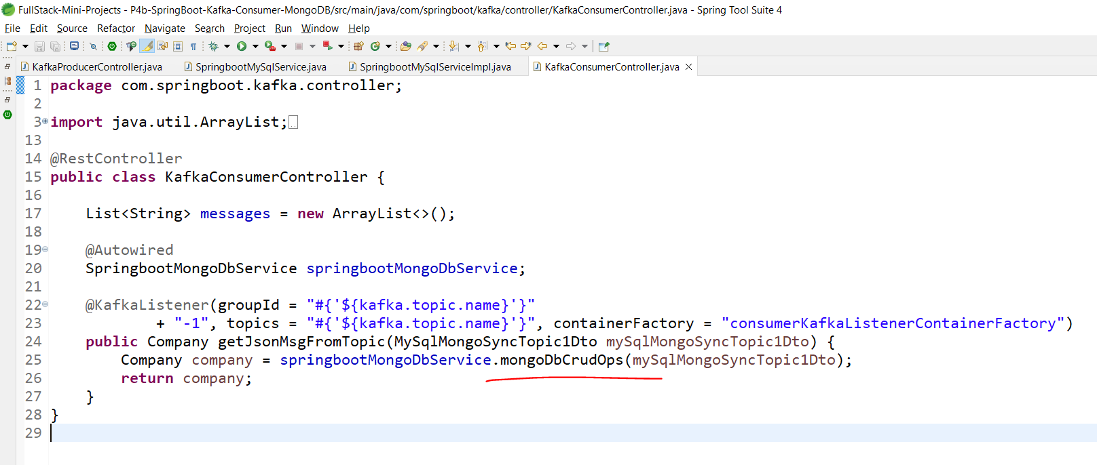

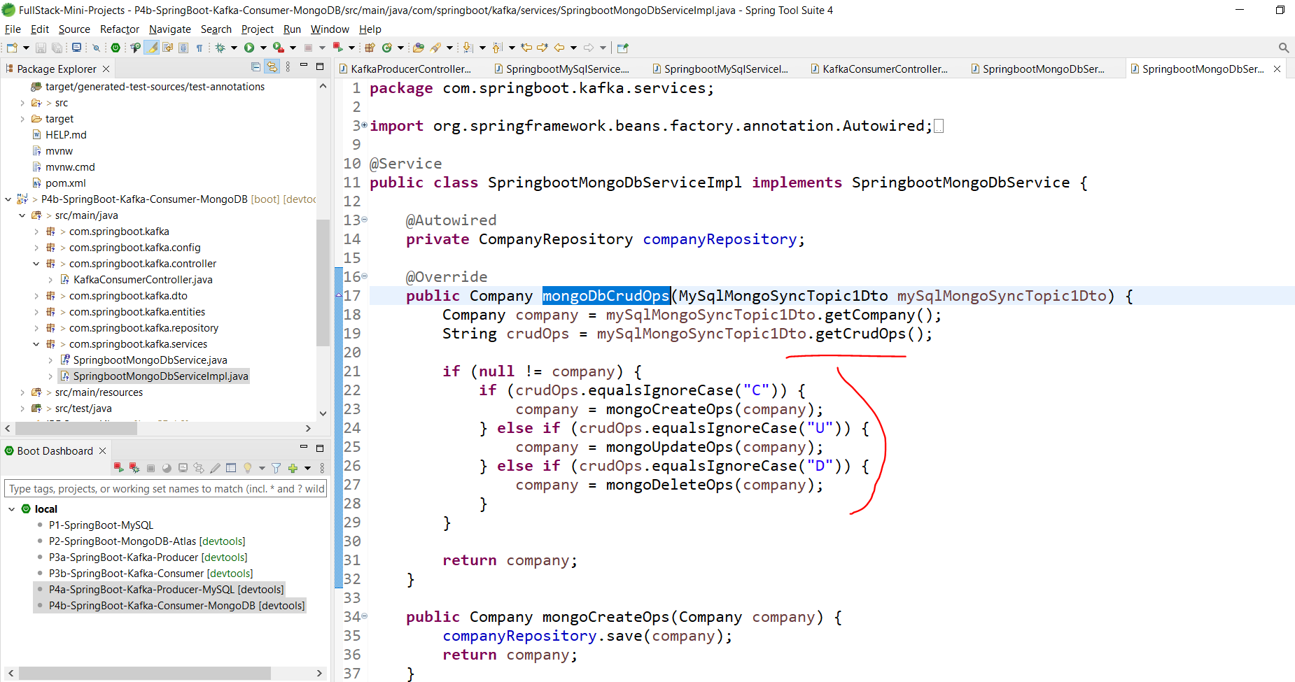

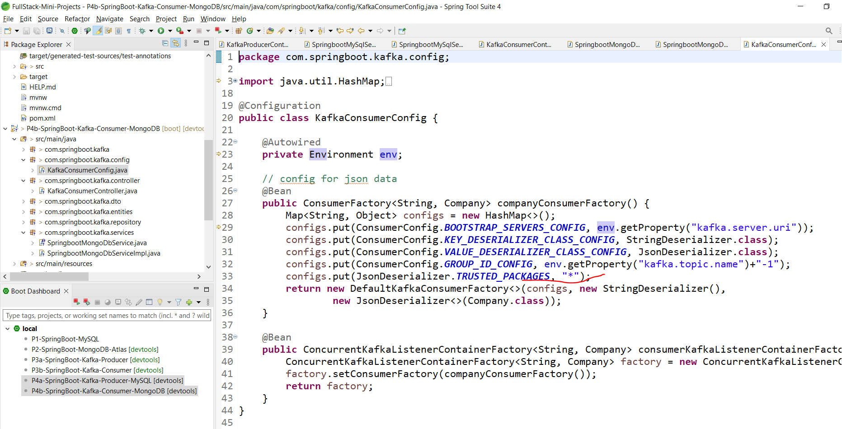

Here instead of \* we can mention the DTO packages to deserialize.

Postman:

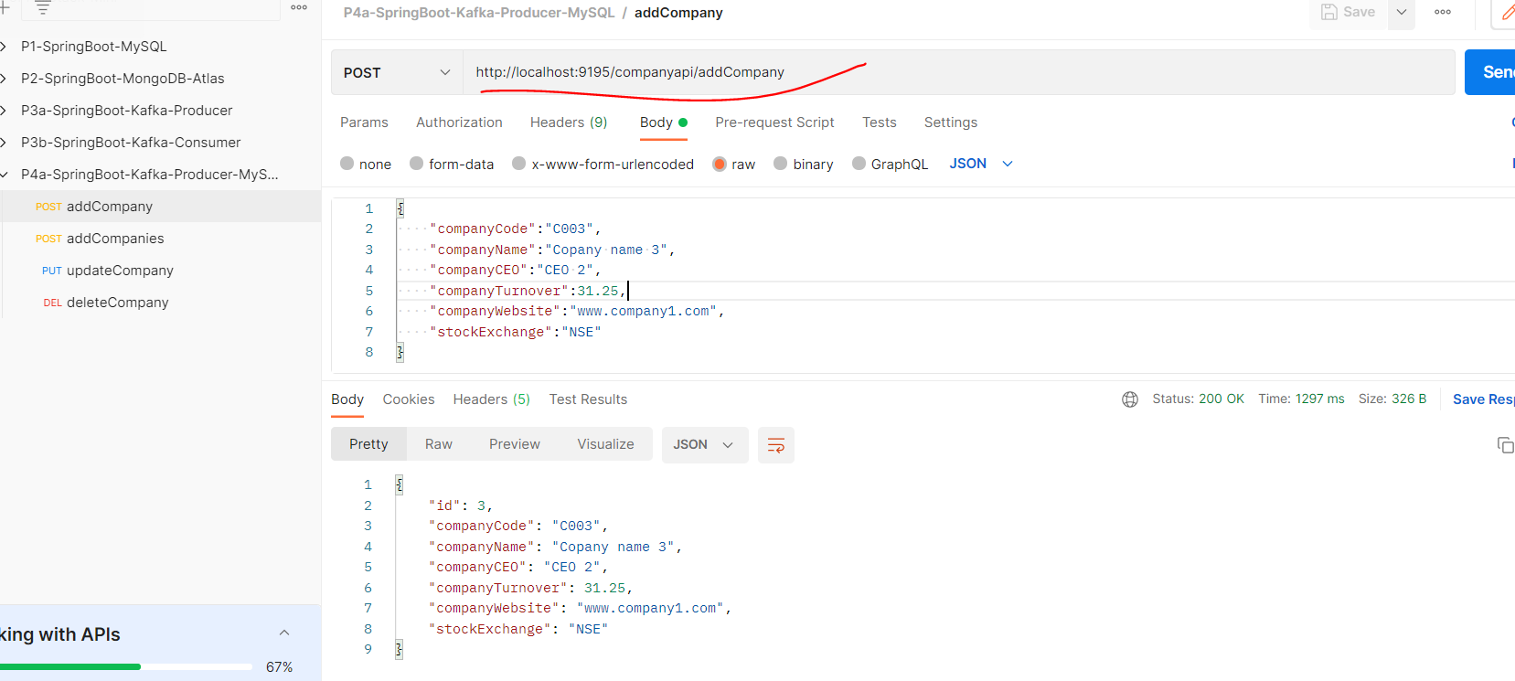

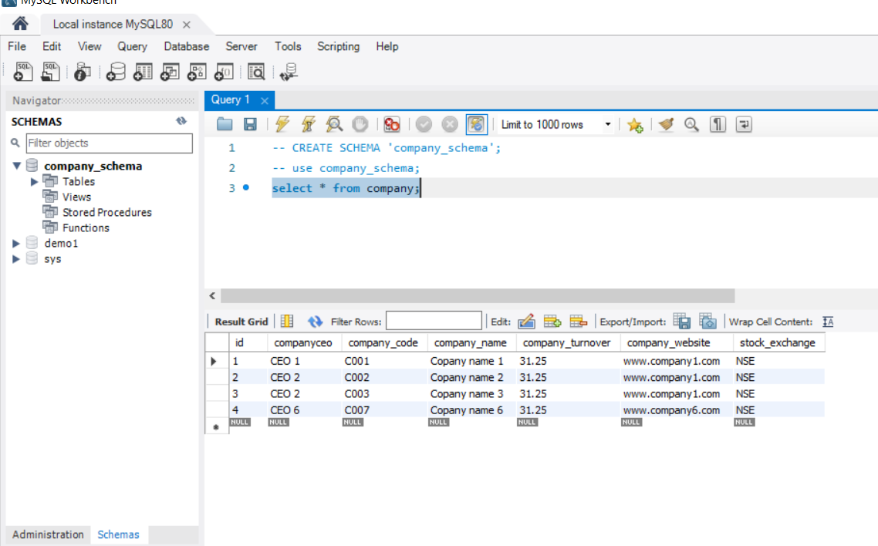

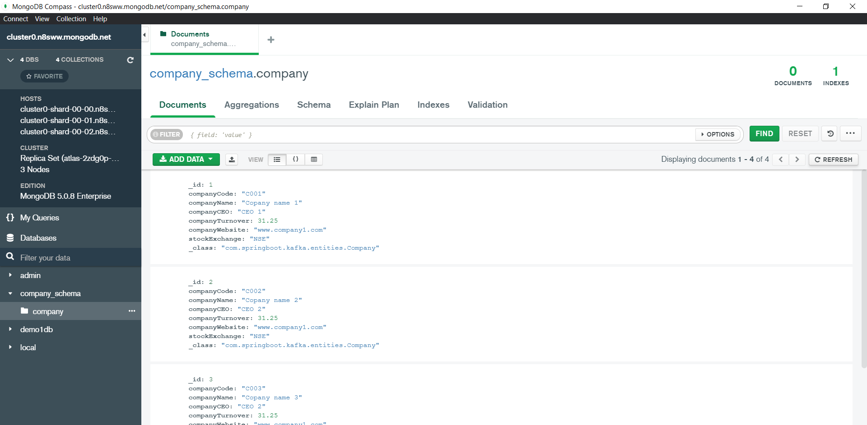

Both DBs are in sync now.